**Suggestions for Improvement**

1. **Add validation messages** for numeric fields (e.g., "Only numbers allowed", "Discount must be between 1–100%").
2. **Display the discounted amount and original price** during purchase for transparency.
3. Include a **confirmation prompt** before applying discount changes (to avoid accidental updates).
4. Add **logging/audit trail** for admin changes (security and tracking).
5. Define maximum value for course_count (e.g., max 100?).

**Clarification Questions**

1. What roles exist in the system besides Admin and Non-Admin (e.g., Guest, Registerted User)?
2. Can discounts be configured globally, or per user/course?
3. Is there a maximum or minimum discount allowed?
4. Is the discount a percentage or a fixed amount?
5. Should the discount apply only once per user or per course purchase?
6. Can an admin configure **different discounts** for Fundamental vs Advanced courses?
7. What database tables/columns reflect these changes?
8. Does “course_count” limit the number of discounted purchases per user?
9. Should the discount have a start and end date?
10. Is there a time limit after which the discount becomes invalid?
11. What if both Advanced and Fundamental discounts are configured — will they apply together?
12. Can a user buy more than one course at once? If so, how is discount applied?
13. What if admin sets discount to 0 or 100? Should the system allow that?

**Bug Report**

|  |  |
| --- | --- |
| ID number | #111 |
| Bug Summary | ‘’Change Discount’’ button is available after invalid input in ‘discount field’ |
| Reporter | Diana Margaryan |
| Submit Date | 15.05.2025 |
| Platform | Qwallity app. |
| Operating System | MacOS |
| Browser | Chrome |
| Severity | Critical |
| Priority | High |

**Precondition**: Application is opened   
Admin user is logged in  
Admin is on Change Discount screen

**Description:**

I can click on ‘’Change Discount’’ button when I input invalid data in discount field (like abc) after that ‘’Discount is changed’’ message is displayed.

**Steps to reproduce**

1. Enter abc in discount field

2. Click "Change Discount"

**Expected result**

Validation message: "Invalid input"

**Actual result**

Button is clickable and ‘’Discount is changed’’ message is displayed.

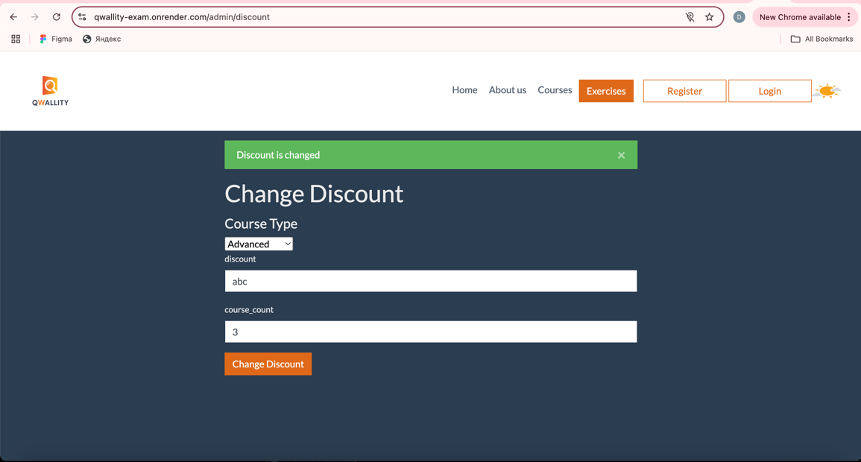

|  |  |
| --- | --- |
| ID number | #112 |
| Bug Summary | ‘’Change Discount’’ button is available after leaving all fields empty |
| Reporter | Diana Margaryan |
| Submit Date | 15.05.2025 |
| Platform | Qwallity app. |
| Operating System | MacOS |
| Browser | Chrome |
| Severity | Critical |
| Priority | High |

**Precondition**: Application is opened   
Admin user is logged in  
Admin is on Change Discount screen

**Description:**

I can click on ‘’Change Discount’’ button when I leave all fields empty. After clicking on ‘Change Discount’ button ‘’Discount is changed’’ message is displayed.

**Steps to reproduce**

1. Leave all fields blank

2. Click "Change Discount"

**Expected result**

Validation message should appear

**Actual result**

Button is clickable and ‘’Discount is changed’’ message is displayed.

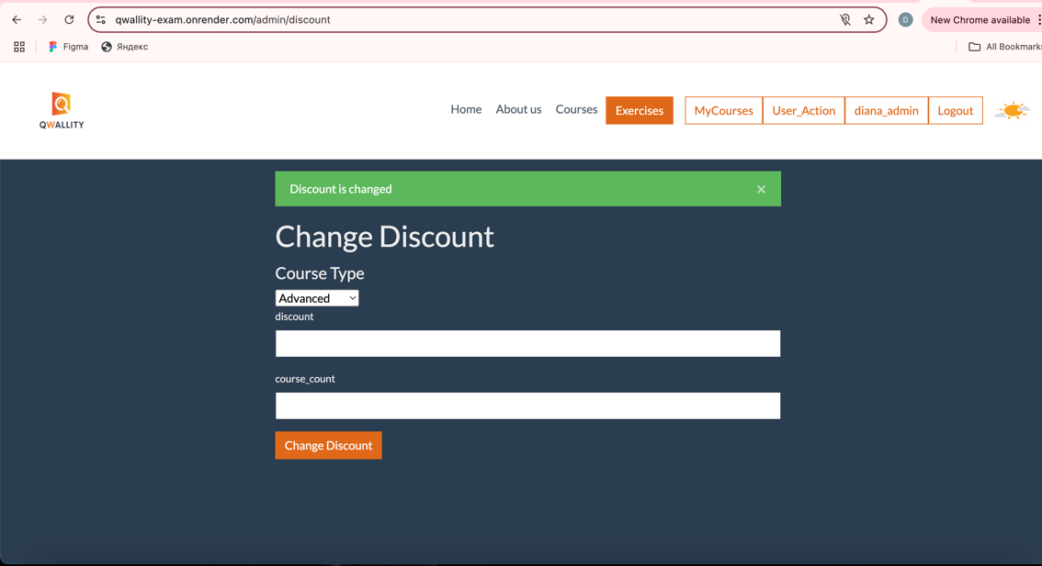

|  |  |
| --- | --- |
| ID number | #113 |
| Bug Summary | ‘’You have 0 discount’’ message is displayed |
| Reporter | Diana Margaryan |
| Submit Date | 15.05.2025 |
| Platform | Qwallity app. |
| Operating System | MacOS |
| Browser | Chrome |
| Severity | Medium |
| Priority | Medium |

**Precondition**: Application is opened   
Non Admin user is logged in

**Description:**

When I am trying to buy an ‘’advanced’’ course the following message is displayed You have 0 discount. Discounted price is displayed.

**Steps to reproduce**

1. Navigate to courses
2. Click on ‘’Advanced’’
3. Choose one course and click on buy

**Expected result**

Standard price is displayed, no message is shown

**Actual result**

The following message is displayed You have 0 discount. Discounted price is displayed.

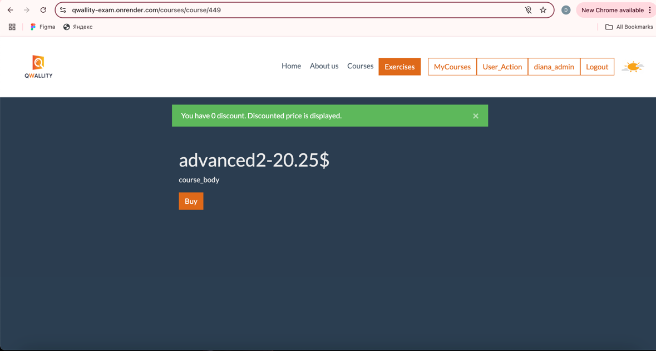

|  |  |
| --- | --- |
| ID number | #114 |
| Bug Summary | Message about having discount is shown when buying the first course |
| Reporter | Diana Margaryan |
| Submit Date | 15.05.2025 |
| Platform | Qwallity app. |
| Operating System | MacOS |
| Browser | Chrome |
| Severity | Critical |
| Priority | High |

**Precondition**: Application is opened   
Non Admin user is logged in

**Description:**

When I am trying to but my first advanced course, it shows a message about having discount.

**Steps to reproduce**

1. Navigate to courses
2. Click on ‘’Advanced’’
3. Choose one coure and click on buy

**Expected result**

Standard price is displayed, no message is shown

**Actual result**

The following message is displayed You have 40 discount. Discounted price is displayed.

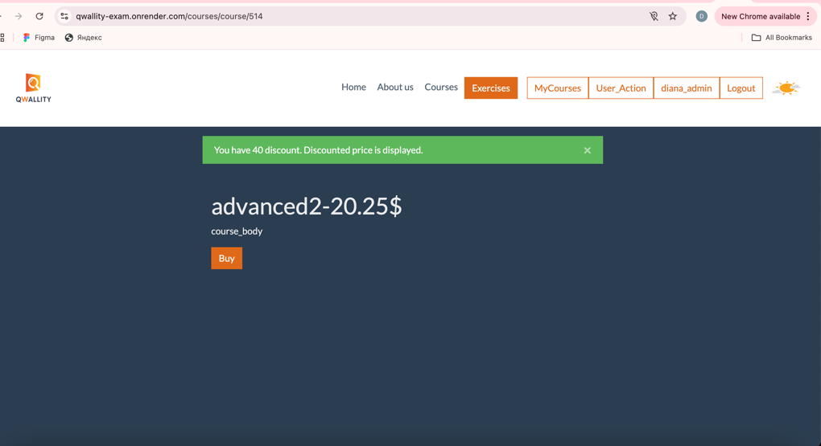

|  |  |
| --- | --- |
| ID number | #115 |
| Bug Summary | The price of the course is not changed, when it should be discounted |
| Reporter | Diana Margaryan |
| Submit Date | 15.05.2025 |
| Platform | Qwallity app. |
| Operating System | MacOS |
| Browser | Chrome |
| Severity | Critical |
| Priority | High |

**Precondition**: Application is opened   
Non Admin user is logged in  
Non Admin user bought necessary amount of courses to get discount (3).

**Description:**

The price of the course is not changed, when it should be discounted. It shows the message about having discount, but the price is the same.

**Steps to reproduce**

1. Choose the next course (4rth)

2. Click on Buy

**Expected result**

The discounted price is displayed

**Actual result**

The price is the same (not discounted).